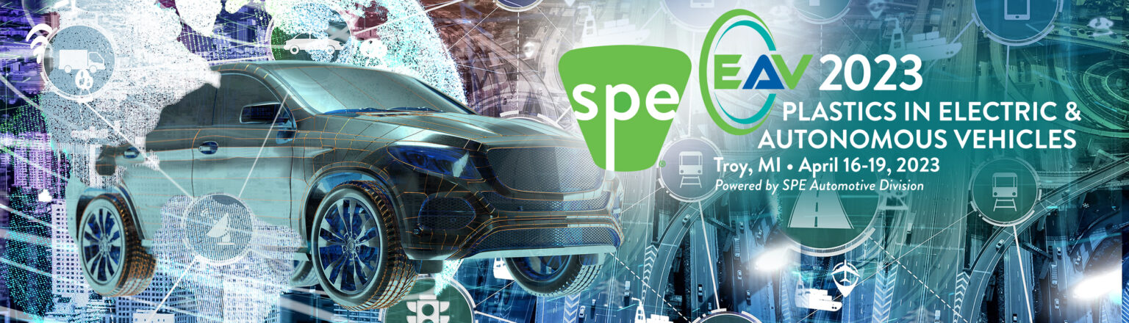FOR IMMEDIATE RELEASE: 11 JANUARY 2023

SPE® EAV - PLASTICS IN ELECTRIC & AUTONOMOUS VEHICLES CONFERENCE ANNOUNCES CALL FOR ABSTRACTS FOR SPE® EAV STUDENT POSTER SCHOLARSHIP COMPETITION ABSTRACTS DUE APRIL 1, 2023

TROY (DETROIT), MICH. - The organizing committee for the SPE® PLASTICS IN ELECTRIC & AUTONOMOUS VEHICLES invites graduate, undergraduate, community college, and high school students to submit abstracts on innovative plastic technologies, for electric & autonomous vehicles, for its second student poster scholarship competition. The competition will be held during the EAV Conference at the Detroit Marriott Troy in Troy, Michigan April 16-19, 2023. Judges who are industry experts, SPE board members and highly skilled individuals from academia will review all posters with student authors on April 17th and April 18th. First-, second-, and third-place awards will be presented to winners in graduate, undergraduate, and high school categories during a special ceremony after lunch on April 18th, 2023.

Students interested in participating in the scholarship competition should contact Dr. Alper Kiziltas, EAV student poster competition chair, via akizilta@amazon.com.

Abstracts are due by April 1st, 2023. Digital copies of posters are due by April 7th, 2023, for pre-review by judges. Students will need to bring printed copies of their posters to the conference, which they can attend free of charge. All students in the competition will also receive a partial travel stipend and a shared hotel room provided by SPE, as well as free student membership in SPE.

Large multi-poster panels and push pins for displaying the posters in the Student Poster Display area will be provided. The show also provides excellent networking opportunities for those close to graduating who are starting to look for a job. Please bring your resume with you.

Please see attached file for the poster template.

Poster topics may include plastics on the following subjects:

- Battery & Thermal Management System
- Advanced Driver Assistance System
- Material Innovations and Lightweighting
- Evolution of Interiors
- Sustainability, Recycling & Carbon Neutrality
- Evolution of Exterior and Vehicle Architectures
- Noise, Vibration, and Sealing
- Advanced Manufac. and Enabling Technol.

Students and their posters are ranked according to the following criteria:

• Content (student and poster demonstrate clarity of topic, objectives, and background);
• Motivation for research and technical relevance to conference theme;
• Methodology and approach to problem;
• Quality of proposed research results/findings;
• Conclusions are supported by information presented;
• Presentation (display aesthetics are pleasing and there is a logical flow between sections);
• Knowledgeable (presenter has a good grasp of the subject);
• Understandability (poster is effective even without student being present to explain it); and
• Overall rank vs. other posters and presenters.

The mission of SPE is to promote scientific and engineering knowledge relating to plastics worldwide and to educate industry, academia, and the public about these advances. SPE’s Automotive Division is active in educating, promoting, recognizing, and communicating technical accomplishments in all phases of plastics and plastic-based composite developments in the global transportation industry. Topic areas include applications, materials, processing, equipment, tooling, design, and development. For more information see https://speautomotive.com/. For more information on the Society of Plastics Engineers, see www.4spe.org.
For more information on the EAV Student Poster Competition, contact:

- Alper Kiziltas, Amazon, akizilta@amazon.com
- Amy Stephen, The Materials Group, amy.stephen@thematerialsgroup.com

